Mateo and Joey | CSC3220 | January 29, 2025

Ocean

Components of ocean

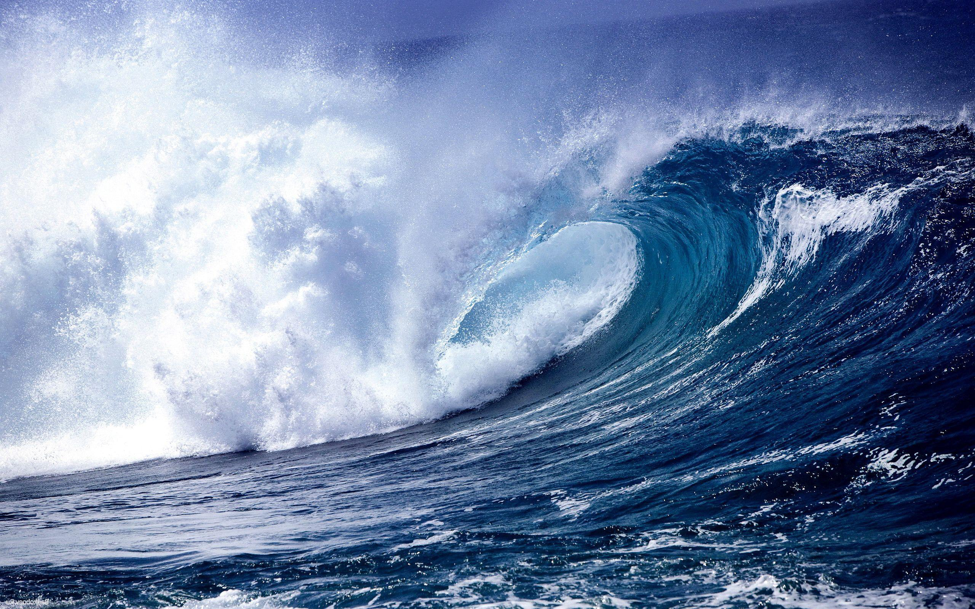

# Summary:

* Basic components:
  + Editor style system
  + Database style storage for Scenes (ECS)
  + Visual system, for proper rendering of items within Scene
  + Audio system, for proper audio playback with respect to Scene.

# Editor:

* UI:
  + Enables easier design of applications within the engine, enabling the developer to adjust properties and visuals of the application easily.
* Scripting/Programming:
  + Enable scripting in a language such as C#, to enable developers to easily implement logic within their application.
* Hot-reloading:
  + Enables developers to quickly do testing of interactions, mechanics and visuals due to the lower overhead of not fully-rebuilding every time.

# Audio System:

* Playback
  + Manages playback of sound effects and music, allowing for 3d effects, such as a specific sound originating somewhere else within the Scene.
* Mixing:
  + May mix audio from multiple sources originating in the scene, as well as modifying the audio, such as echoes, reverb, or volume.
* Streaming:
  + May stream audio from larger files to avoid inserting the entire file into memory, potentially increasing performance
* Resource management:
  + On a case-by-case basis, will decide how to use resources efficiently, i.e whether streaming the audio from a file, or playing it from memory. In addition to that it may move audio out of memory if unused or unneeded.

# Databases:

* Suitability:
  + In most realtime applications, databases are great for realtime data storage, as well as retrieval.
* Use cases:
  + Within Ocean, a database will be used to store data about everything relating to the scene, for the purpose of permanence.

# Real world examples of editors:

* Unity Engine 2021:

* Unreal Engine 4:
  + A computer screen shot of a video game

    Description automatically generated
* Blender 4.2
  + A screenshot of a computer

    Description automatically generated

# Image Credit:

* Unity:
  + <https://calissat.github.io/ws/jupyter/testprep/2023/05/23/first-project.html>
* Unreal Engine:
  + https://www.youtube.com/watch?v=9CZ3CpHUwkM